**Peer to Peer Fundraiser Tool Kit**

go.dojiggy.io/youreventname

Here’s your mission and vision statement.

Why should supporters make the effort for your organization?

What makes your organization unique and wonderful?

**Why We Walk**

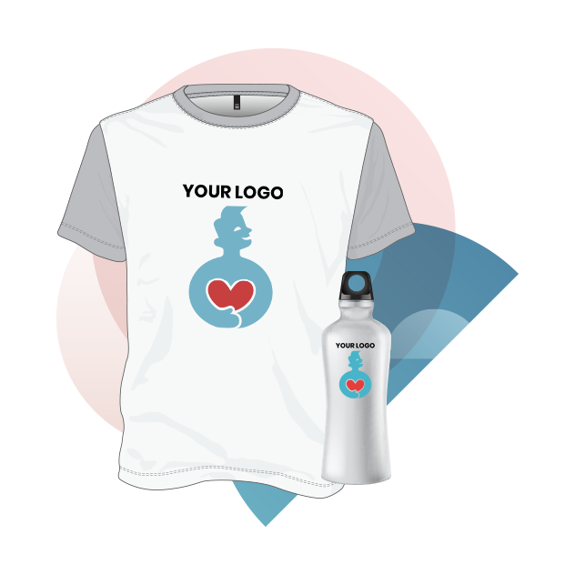

**Participants that raise $250+ will get a free event t-shirt, plus a stainless steel water bottle.**

**Participants that raise $50+ will get a free event t-shirt**

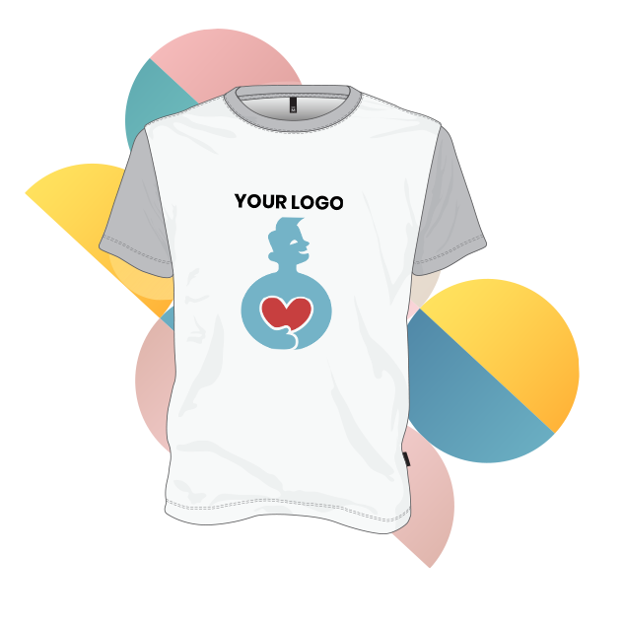

**Top Fundraising Individual**

List your prize here!

This year’s Walk will feature all-new incentive levels and a great celebration you won’t want to miss. Top fundraisers will be recognized at the post-walk celebration.

**Top Fundraising Team**

List your prize here!

**Prizes & Incentives**

Ask friends and family to support your fundraising efforts with a donation

Show your commitment by making a personal donation

Always remember to say Please and Thank You!

Talk about the cause and share your page on email and Social media channels

Ask friends and family to join the campaign and participate with you!

Register as an individual or a team at go.dojiggy.io/youreventname

Create your fundraising goal and custom page link at registration or in your dashboard

Customize your fundraising page - add images and a personalized donation appeal

**FUNDRAISE**



**CONNECT**



**SIGNUP**



**Participant Checklist**

For many fundraisers, it can be difficult to ask friends, family members, and acquaintances for financial support. Start with those you know will be willing to support you and use this to build momentum

**How to Fundraise**

A personal fundraising ask still works best in many cases. Ask for off-line pledge forms, if you want to collect cash or check donations off-line.

 Potential supporters that you see often and may not connect with online include:

* Work acquaintances: Bosses, co-workers, business partners, vendors, clients
* Associates from group activities: Teammates, coaches, classmates
* Members of your church or spiritual group
* Neighbors
* Local Relationships: Hairstylists, dentists, or mail carriers

**Fundraise The Old Fashion Way**

**Use Social Media**

Social media is a casual and fun way to have direct conversations with supporters, share fundraising updates, build awareness for the cause, and inspire giving.

* Share Your Story - Create a video and/or post pictures sharing the reasons why you walk and what the cause means to you.
* Use our Hashtags - Stories with hashtags will generate more traffic and boost your fundraising. #WALK
* Include a Call to Action -Ask friends to join you! Find ways to get people to engage in your fundraising
* Interact with your friends in real-time while you engage and grow your audience by showcasing your unique story via a live stream

Most potential donors will be people you personally know - friends, relatives, co-workers, and others within your social network. Often their decision to donate is because they are supporting you, rather than supporting the cause. For this reason, **inspiring your supporters is key to your success**. You need to explain why you have chosen to participate, what the event and charity mean to you, and how their contribution can help the organization achieve its goals.

**Customize Your Fundraising Page**

You’ve worked hard to gather your donations. Now, honor all that have supported you by having the best race possible.  The following will help boost your energy and keep unwanted accidents from happening.

* Eat a good breakfast. You’ll need fuel to keep your energy going
* Wear comfortable and supportive shoes. Don’t wait until event day to break in a new pair.
* Protect yourself from the sun!
* Stay hydrated. Bring water and sports drinks.
* Arrive early to register and stretch.
* Don’t push too hard. It’s okay to reach for your best time or distance, but make sure you don’t overdo it.
* Bring your smile. We want you to have fun!

Don’t forget to follow up and thank your donors. Let them know about our success and how they made a difference!

**Contact Us**

We’re here to help you succeed! Call us at (888)123-4555 or email us at walk@org.org.

**The Big Day and Beyond**